|  |  |
| --- | --- |
| **Name:** | MANSI UNIYAL |
| **Roll Number:** | 19EE10039 |

**Experiment No.**

**Name of the Experiment: BJT Common Emitter Characteristics**

1. **Aim of the experiment**

Explain Common Emitter characteristics of a BJT

1. **Tools used:**

* Stimulation: Vlabs
* Connecting wires
* Resistances
* Capacitors
* Sinusoidal input voltage source
* BJT (Bipolar Junction Transistor)

1. **Background knowledge (brief):**

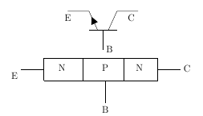

* **Structure of Bipolar Junction Transistor**

A bipolar junction transistor, BJT, is a single piece of silicon with two back-to-back P-N junctions. BJT’s can be made either as PNP or as NPN. They have three regions and three terminals, emitter, base, and collector represented by E, B, and C respectively. The direction of the arrow indicates the direction of the current in the emitter when the transistor is conducting normally. An easy way to remember this is NPN stands for "Not Pointing in".

* **Emitter (E):** It is the region to the left end which supply free charge carriers i.e., electrons in n-p-n or holes in p-n-p transistors. These majority carriers are injected to the middle region i.e. electrons in the p region of n-p-n or holes in the n region of p-n-p transistor. Emitter is a heavily doped region to supply a large number of majority carriers into the base.
* **Base (B):** It is the middle region where either two p-type layers or two n-type layers are sandwiched. The majority carriers from the emitter region are injected into this region. This region is thin and very lightly doped.
* **Collector (C):** It is the region to right end where charge carriers are collected. The area of this region is largest compared to emitter and base region . The doping level of this region is intermediate between heavily doped emitter region and lightly doped base region.
* **Operation of Bipolar Junction Transistor**
* 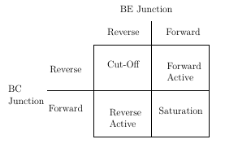**Cutoff Region:** Base-emitter junction is reverse biased. No current flow.
* **Saturation Region**: Base-emitter junction is forward biased and Collector-base junction is forward biased.
* **Active Region**: Base-emitter is junction forward biased and Collector-base junction is reverse biased.
* **Breakdown Region:** IC and VCE exceed specifications and can cause damage to the transistor.
* 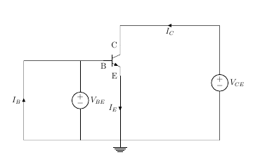**Output Characteristics**
* The most important characteristic of the BJT is the plot of the collector current, IC, versus the collector-emitter voltage, VCE, for various values of the base current, IB as shown on the circuit on the right.
* **Input Characteristics**
* The most important characteristic of the BJT is the plot of the base current, IB, versus the base-emitter voltage, VBE, for various values of the collector-emitter voltage, VCE
* The DC behavior of the BJT can be described by the Ebers-Moll Model.
* α = β/(1+β)

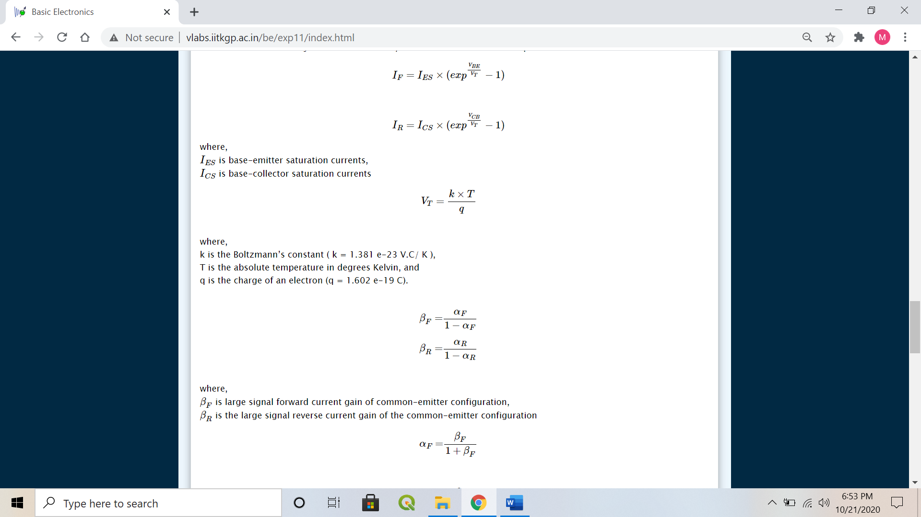



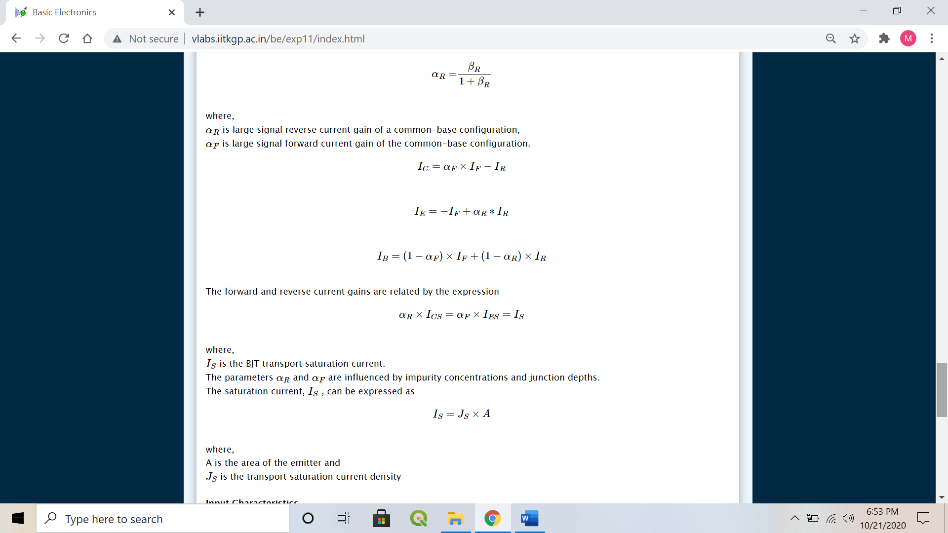





1. **Circuit (hand drawn/image)**

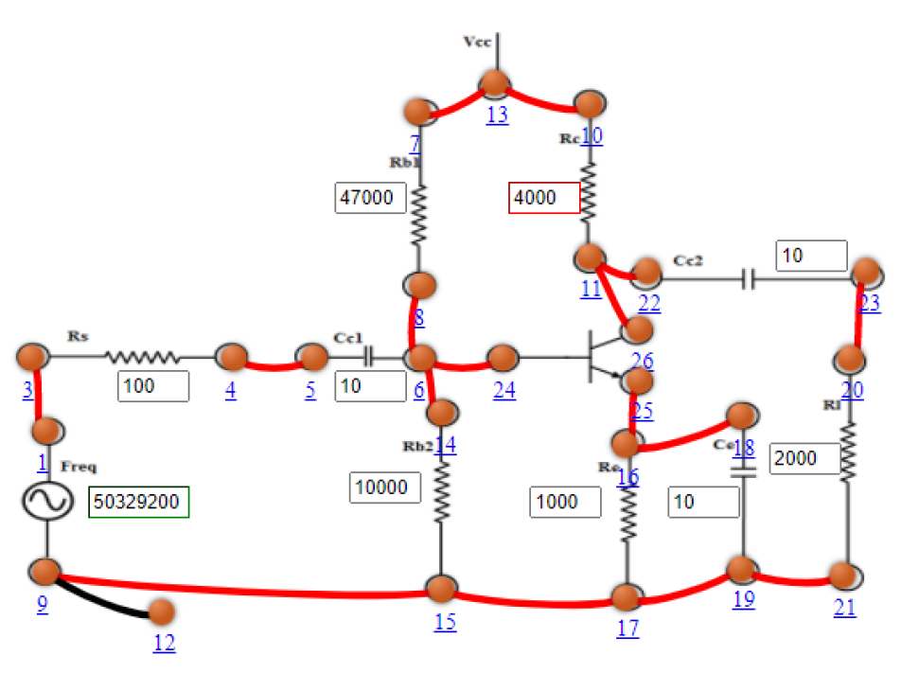

1. **Measurement Data (Tabular form)**

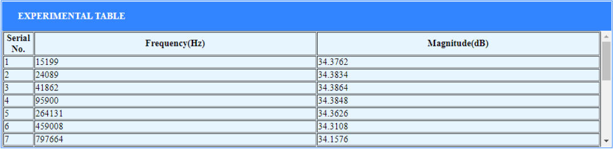

1. **Graph (Image)/Screenshots**

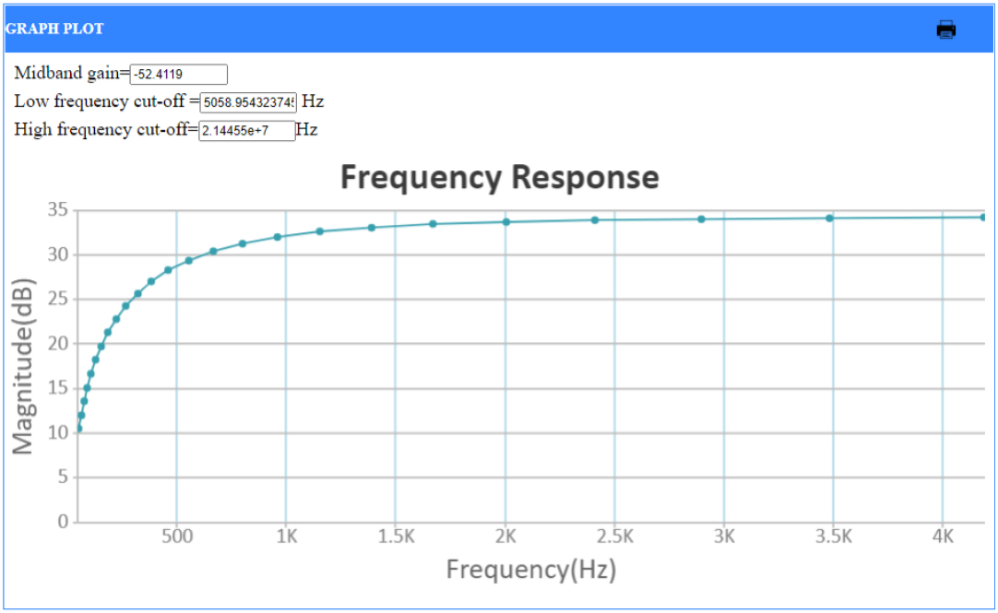

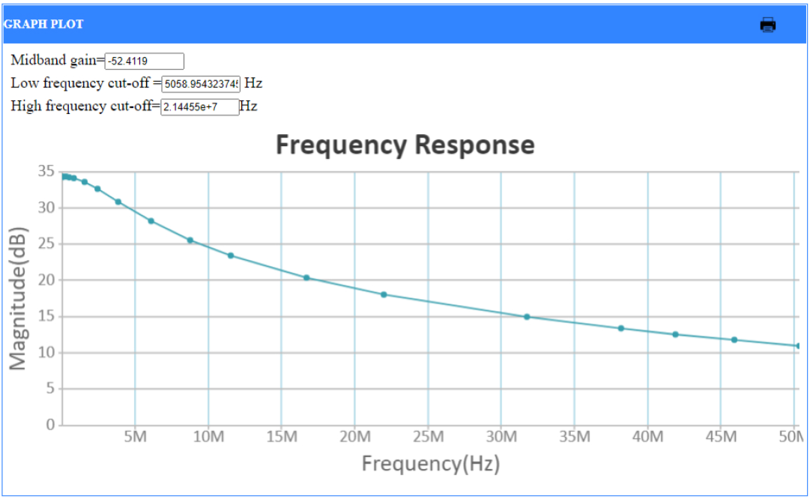

1. **Conclusion**

* **Input characteristics:**
  + IB = ϕ (VBE, VCE) for constant VCE
* **Output characteristics:**
  + IC = ϕ (VCE, IB) for constant IB

1. **Discussions**

* Cut-Off Region
  + Application: Open switch
* Forward Active Region
  + Application: Amplifier in analog circuits
  + IC = −αF × IE + ICO
    - where,

αF is the forward current transfer ratio

ICO is Collector reverse saturation current

* Saturation Region
  + Application: Closed switch
* Reverse Active Region
  + Application: In digital circuits and analog switching circuits.
  + IE=−αR∗IC+IEO
    - where,

αR is the reverse current transfer ratio\newline

IEO is the Emitter reverse saturation current

1. **Quiz**

